PROJECT REPORT
Project Title: Import Data Using Transform Maps in ServiceNow

1. INTRODUCTION

1.1 Project Overview
This project demonstrates an end-to-end employee data import process in ServiceNow using Import Sets and Transform Maps. Employee information is prepared in an Excel/Google Spreadsheet, loaded into an Import Set table, mapped to a custom Employee Test table, and transformed into usable ServiceNow records. The project also includes Coalesce configuration to prevent duplicate records and Reports and Dashboards to provide a centralized view of employee information and import activity.

1.2 Purpose
The purpose of the project is to understand and implement bulk data migration in ServiceNow accurately and efficiently. It provides practical knowledge of loading external spreadsheet data, creating a staging table, mapping source and target fields, executing transformations, updating existing records, avoiding duplicates, and presenting the imported information through reports and dashboards.

2. IDEATION PHASE

2.1 Problem Statement
Organizations may receive employee information in spreadsheet format and need to move large amounts of data into ServiceNow. Manual entry is time-consuming and can introduce errors or duplicate records. A structured import process is therefore required to load external data, map it correctly, update existing records, and maintain reliable employee information.

2.2 Empathy Map Canvas
Think & Feel | See | Hear | Do
Needs accurate employee records and a simple way to manage repeated imports. | Excel files, ServiceNow tables, import status, reports and dashboards. | Requirements for accurate migration, duplicate prevention and validation. | Prepares spreadsheet data, loads it, maps fields, transforms records and verifies results.

2.3 Brainstorming
The project idea was developed around a simple automated workflow: prepare structured employee data, create a custom target table, load the spreadsheet into an Import Set, create a Transform Map, map source fields to target fields, execute the transformation, use Coalesce for duplicate prevention, and create reports and a dashboard for monitoring.

3. REQUIREMENT ANALYSIS

3.1 Customer Journey map
Stage | User Activity | System Response
Prepare Data | Create spreadsheet with employee details. | Spreadsheet is ready for import.
Load Data | Use Load Data and select the Excel file. | Data is loaded into the Import Set table.
Map Data | Configure the Transform Map and field mappings. | Source fields are connected to target fields.
Stage | User Activity | System Response
Transform | Run the transformation. | Records are inserted or updated.
Validate | Check transform history and Employee Test table. | Import status and records can be verified.
Analyze | Open reports and dashboard. | Employee information is presented visually.

3.2 Solution Requirement
- ServiceNow instance with access to tables, Import Sets, Transform Maps, Reports and Dashboards.
- Excel/Google Spreadsheet containing structured employee data.
- Custom target table: Employee Test (u_employee_test).
- Import Set table: Employee Import (u_employee_import).
- Transform Map connecting Employee Import to Employee Test.
- Required fields: Employee ID, Employee Name, Email, Department and Location.
- Coalesce enabled on a suitable unique field such as Employee ID.
3.3 Data Flow Diagram

External Spreadsheet
↓
Load Data
↓
Import Set Table Employee Import
↓
Transform Map
Source → Target Field Mapping
↓
Employee Test Table
↓
Reports & Dashboard

3.4 Technology Stack
Technology / Tool | Purpose
ServiceNow | Platform for data import, transformation, storage and reporting.
Import Sets | Staging area for external spreadsheet data.
Transform Maps | Maps source fields to target fields and transforms records.
Excel / Google Spreadsheet | Source of structured employee data.
Reports | Visualizes employee data by department, location and list.
Dashboard | Combines reports into a centralized view.

4. PROJECT DESIGN

4.1 Problem Solution Fit
The project directly addresses spreadsheet-to-ServiceNow data migration. Instead of entering employee records manually, the Import Set provides a staging area and the Transform Map automates field mapping and record creation or updating. Coalesce further supports repeated imports by identifying existing records and avoiding unnecessary duplicates.

4.2 Proposed Solution
- Create the Employee Test custom table with the required employee fields.
- Create the Employee Import Import Set table.
- Load employee spreadsheet data into the Import Set.
- Create the Sample Spreadsheet Import Transform Map.
- Map Employee ID, Employee Name, Email, Department and Location.
- Run the transform and verify the imported records.
- Enable Coalesce to update matching employee records instead of inserting duplicates.
- Create department, location and employee list reports and combine them in a dashboard.

4.3 Solution Architecture
Data Source Layer: Excel/Google Spreadsheet → Staging Layer: Employee Import Import Set → Transformation Layer: Transform Map + Field Maps + Coalesce → Target Layer: Employee Test Table → Presentation Layer: Reports + Employee Analytics Dashboard.

5. PROJECT PLANNING & SCHEDULING

5.1 Project Planning
Phase | Planned Activity
Phase 1 | Prepare spreadsheet data.
Phase 2 | Create Employee Test custom table and fields.
Phase 3 | Create and load the Employee Import table.
Phase 4 | Create Transform Map and configure field mappings.
Phase 5 | Transform data and validate records.
Phase 6 | Enable Coalesce and test duplicate prevention.
Phase 7 | Import additional Excel data and verify insert/update behavior.
Phase 8 | Create reports.
Phase 9 | Create dashboard and add reports.

6. FUNCTIONAL AND PERFORMANCE TESTING

6.1 Performance Testing
- Verify that spreadsheet data is successfully loaded into the Import Set table.
- Verify that all required source and target fields are mapped correctly.
- Verify that the Transform operation completes successfully.
- Verify that imported records appear in the Employee Test table.
- Verify that Coalesce updates an existing employee record when the matching Employee ID is imported again.
- Verify that repeated import of the same data does not create additional duplicate records.
- Verify that reports display department-wise, location-wise and employee-list information.
- Verify that all three reports are successfully displayed on the Employee Analytics Dashboard.
Observed validation from the guideline workflow: during the repeated-data test, the transform history can show inserted and updated records for changed/new data, while re-importing the same unchanged sheet can result in ignored records. This demonstrates the intended duplicate-control behavior.

7. RESULTS

7.1 Output Screenshots
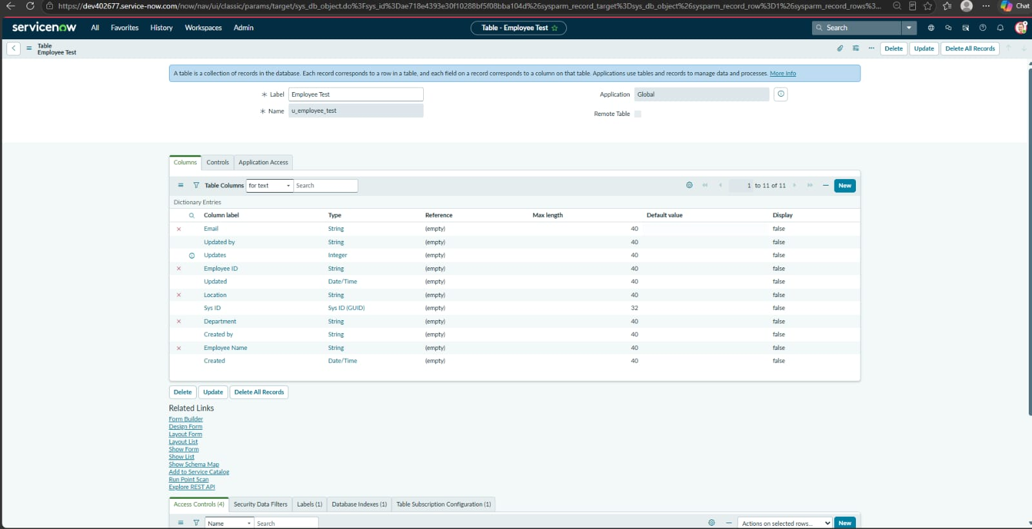

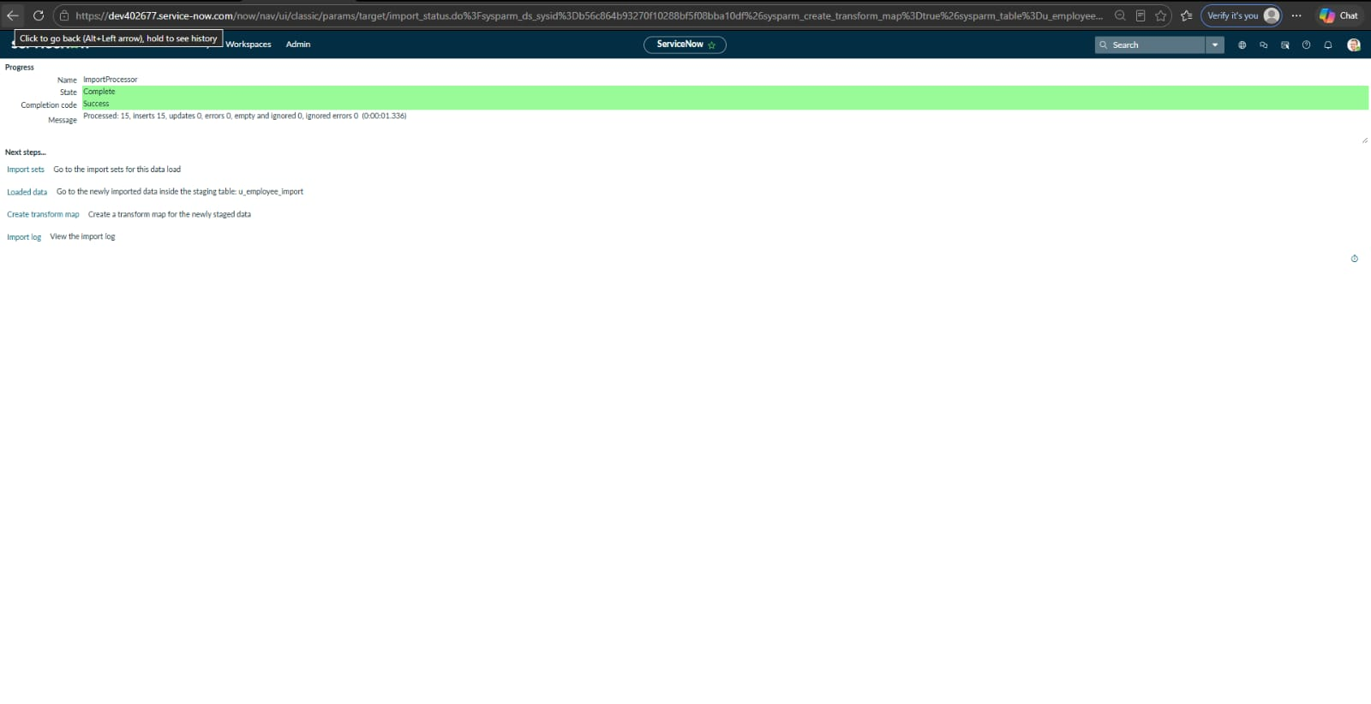
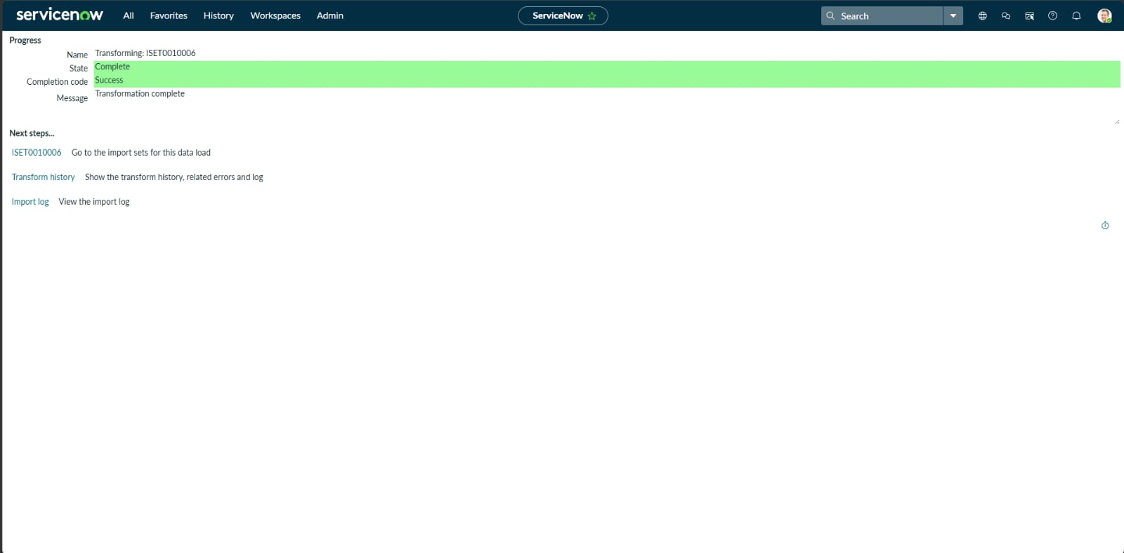

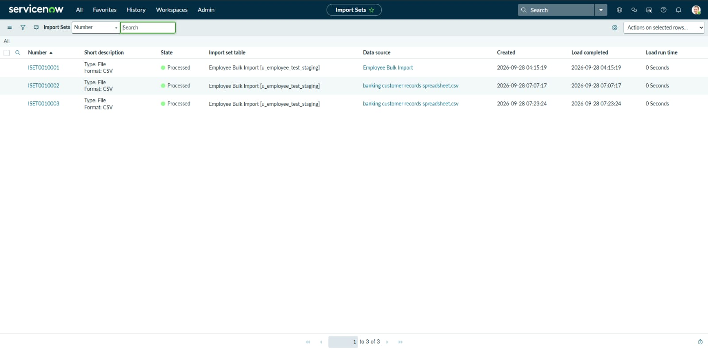
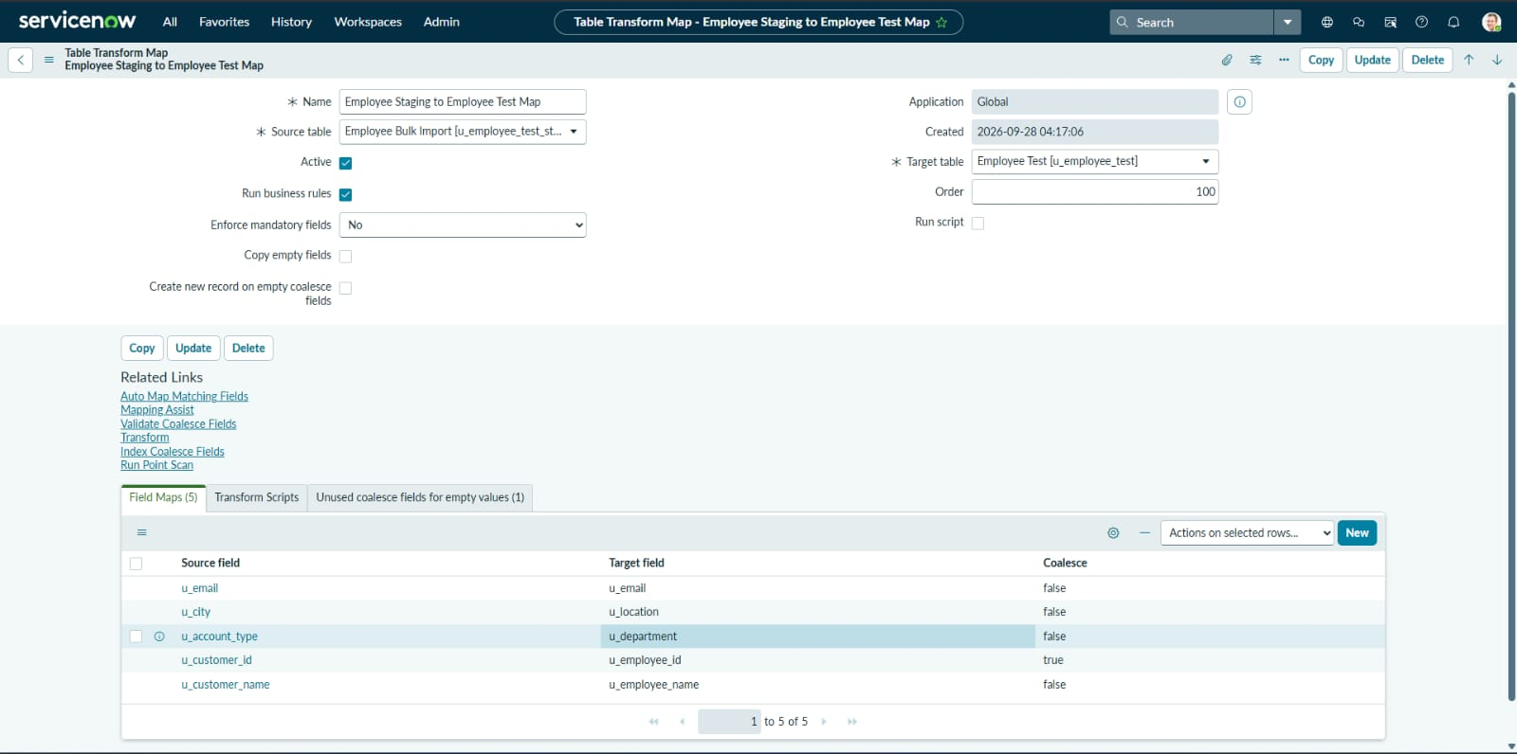

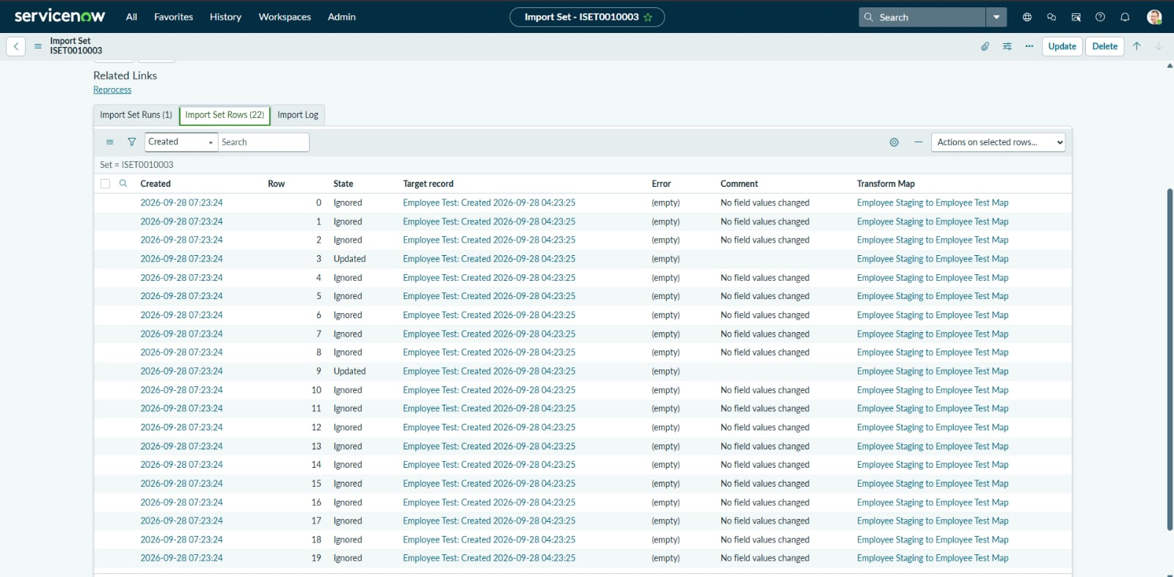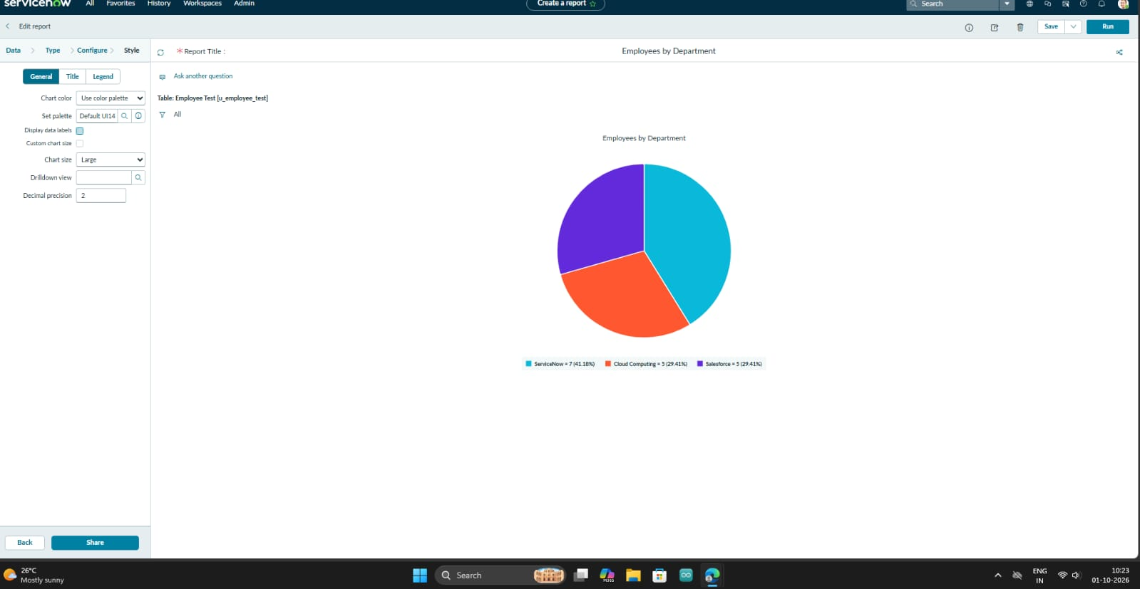
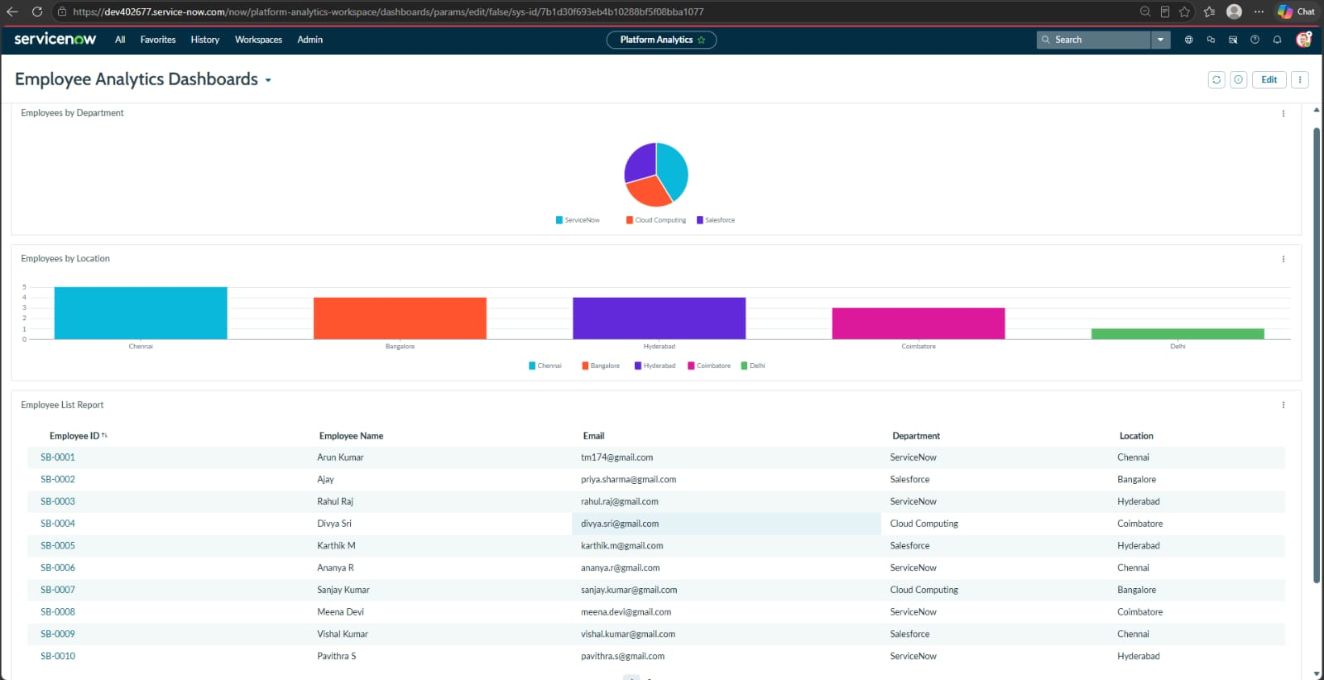

8. ADVANTAGES & DISADVANTAGES

Advantages
- Reduces manual data entry for bulk employee records.
- Provides structured source-to-target field mapping.
- Supports repeated imports and record updates.
- Coalesce helps prevent duplicate records.
- Transform history provides import validation information.
- Reports and dashboards provide centralized visibility into employee data.

Disadvantages
- The spreadsheet must follow the expected structure and field format.
- Incorrect field mapping can produce inaccurate target records.
- The project depends on appropriate ServiceNow access and configuration permissions.
- Large or inconsistent source files may require additional data validation before import.

9. CONCLUSION
The project successfully demonstrates employee data migration into ServiceNow using Import Sets and Transform Maps. The workflow covers spreadsheet preparation, staging, source-to-target field mapping, transformation and validation. Coalesce extends the solution by identifying matching employee records and supporting updates instead of unnecessary duplicate insertion. Reports and the Employee Analytics Dashboard provide a centralized way to view employee information and import-related results. Overall, the project provides a practical understanding of an automated ServiceNow data import workflow.

10. FUTURE SCOPE
- Add additional employee fields and validation rules.
- Introduce automated scheduled imports for regularly received spreadsheets.
- Add more detailed error reporting and data-quality checks.
- Extend dashboards with additional employee and import-performance metrics.
- Integrate the workflow with other external data sources where required.
- Add role-based access controls for different administrative users.

11. APPENDIX

Source Code (if any)
No separate application source code is required for the core workflow; the implementation is configured inside ServiceNow using tables, Import Sets, Transform Maps, field mappings, Coalesce, Reports and Dashboards.

Dataset Link
https://docs.google.com/spreadsheets/d/1ci0BReRAHscecwd3dYWmLrDP1lcZRdBT/edit?usp=sharing&ouid=110449630628915607184&rtpof=true&sd=true

GitHub & Project Demo Link
https://github.com/rajikalairaji1-prog/service-now-transform-map-project.git
https://drive.google.com/file/d/1bYacbJKLNirJWDXSezjlbTLQlhgUXU66/view?usp=sharing

